Martin Simonson

NREM 585

April 1, 2020 (Late Submission)

Case Study #9: National Parks, Wilderness, Grazing/Soil

1. Describe key differences between Antiquities Act (1906) and the National Park Service Organic Act (1916).

The Antiquities Act allowed the US President to designate federally-owned lands as areas protected from development and exploitation due to historical, cultural, and scientific value. However, administration of these areas was not specified. The National Park Service Organic Act created the NPS and designated roles and salaries within the NPS. The language requiring the NPS to preserve natural areas unimpaired for future generations is ambiguous, but noble.

1. Answer these:
   1. There are 158 National Monuments in the US.
   2. The most recent monument is Camp Nelson, KY, established 10/26/2018. The first monument is Devils Tower, WY, established 9/24/1906.
   3. The largest monument (by area) that has not been re-designated into a national park or preserve is the Mojave Trails, CA, at 1.6 M acres. The smallest monument (by area) is a cross at Niagara, but that was given to the state of New York so the current smallest monument is Stonewall, NY at 0.12 acres.
   4. Iowa’s only National Monument is Effigy Mounds, in the NE corner of the state and on the Mississippi River. It is 1,204 acres in size, designated by Harry Truman in 1949. The Native American burial mounds are located on high bluffs (avoiding floods) and are usually depictions of animals (e.g., bears, birds) but some are lines or circles. The mounds were actually excavated by white men and then re-built, which is what white guys do apparently. I have a magnet from here on my fridge.
   5. Bears Ears monument was a particularly contentious monument designation by President Obama. Aside from the geological features of the twin buttes (the “bear’s ears”) there are numerous sites of cultural history, from Native Americans to early pioneers. There are unique/rare flora and fauna present, signifying a scientific value. However, President Trump’s proclamation on December 4, 2017 significantly reduced the area set aside for the monument by President Obama, claims that many of the plants and wildlife are actually not rare, and that most of the land was already protected/managed as wilderness by the BLM. However, the monument designation would have imposed more restrictions (e.g., grazing, ORV use) and therefore the modifications in President Trump’s proclamation reversed many of these restrictions. I seriously doubt President Trump wrote this proclamation himself, which leads to the question of just who wrote it for him to sign.
2. Describe how legislation around National Park establishment differed in the western part of the US vs. the eastern part of the US.

In the west, much of the land was considered non-usable (e.g., desert, badlands) and in the public domain. Therefore, little controversy arose from designation of National Parks in the west. These areas often centered on geographic landforms and unique areas that were unlikely to be agriculturally productive. In the east, however, much of the land was already privately owned and was considered highly productive for agriculture and silviculture. This led to a number of complications, as developed land was unlikely to be returned to a “natural” state and many of the landforms that would create natural park boundaries crossed state lines. As a result, more consideration of interstate cooperation and private ownership hindered creation of National Parks in the east. Many of the eastern National Parks began as national monuments.

1. Answer:
   1. How many National Parks are there in Wyoming? Provide their names and when they were established.
      1. Bighorn Canyon National Recreation Area – October 15, 1966
      2. California National Historic Trail - 1992
      3. Devils Tower National Monument – September 24, 1906
      4. Fort Laramie National Historic Site – March 4, 1931
      5. Fossil Butte National Monument – October 23, 1972
      6. Grand Teton National Park – February 26, 1929
      7. Mormon Pioneer National Historic Trail – November 10, 1978
      8. Oregon National Historic Trail - 1981
      9. Pony Express National Historic Trail – who knows?
      10. Yellowstone National Park – March 1, 1872
   2. How many National Parks are there in North Carolina? Provide their names and when they were established.
      1. Appalachian National Scenic Trail – 1921 to 1937
      2. Blue Ridge Parkway – June 30, 1936
      3. Blue Ridge National Heritage Area – November 10, 2003
      4. Cape Hatteras National Seashore - January 12, 1953
      5. Cape Lookout National Seashore – March 10, 1966
      6. Carl Sandburg Home National Historic Site - 1945
      7. Fort Raleigh National Historic Site – April 5, 1941
      8. Great Smoky Mountains National Park - 1983
      9. Guilford Courthouse National Military Park – October 15, 1966
      10. Gullah/Geechee Cultural Heritage Corridor - 2006
      11. Moores Creek National Battlefield – June 2, 1926
      12. Overmountain Victory National Historic Trail – September 1980
      13. Trail of Tears National Historic Trail – 1987
      14. Wright Brothers National Memorial – March 2, 1927
   3. What other land designations are there? How do these relate to wilderness?

As seen above, there are memorials, corridors, trails, scenic trails and war monuments. Most of the NPS-managed properties that deal with cultural history (e.g., Trail of Tears National Historic Trail) are managed for public access and maintenance of the resource for future generations, whereas the larger parks are managed more for wilderness (although not completely preserved).

1. Considering readings and lectures about grazing, describe the importance of grazing on public land, including challenges and controversy from grazing on public land. Include different perspectives.

Due to the prohibitive nature of some landscapes in the south and west US for row-crop farming, the predominant land use became grazing lands for cattle and sheep. This became an important part of American culture, and cattle drives were a common way to get livestock to large markets in the east. As the landscape became more fragmented and privately-owned, cattle drives became scarce (although they do still exist). In current era, grazing on public lands is controversial. On the one hand, cattle are a necessary commodity in the US and require sufficient grazing areas to sustain large herds. On the other hand, cattle have a detrimental impact on the environment by degrading streams, compacting soils, and browsing flora to the ground. The BLM has introduced fees for grazing rights, limited areas allowed for grazing, and best management practices; these decisions are often “too much regulation” for cattle farmers and “not enough” for environmentalists. The Bundy Standoff of 2014 was an armed confrontation between Cliven Bundy and his supporters, who opposed the BLM seizure of his “trespass” cattle and the federal government’s authority to manage public lands. I cannot believe Bundy was able to make violent threats against the government, block public roads, etc. and all 18 people charged with federal felonies from the incident had the charges dismissed with prejudice. Good thing Cliven Bundy was white.

1. The Soil Conservation Service (SCS) set precedence for the Natural Resource Conservation Service (NRCS), which works with farmers, rangers, and forest landowners across the country to help them boost agricultural productivity and protect natural resources through conservation. The NRCS maintains the Web Soil Survey, which shows soil resources for the continuous (contiguous?) US.
   1. Explore soils on ISU campus, name the two most common soils on ISU campus.

Clarion loam, Bemis moraine, 2 to 6 percent slopes (26.8%) and Wadena loam, 2 to 6 percent slopes (8.9%).

* 1. What are the ratings for non-irrigated capability class on ISU campus?

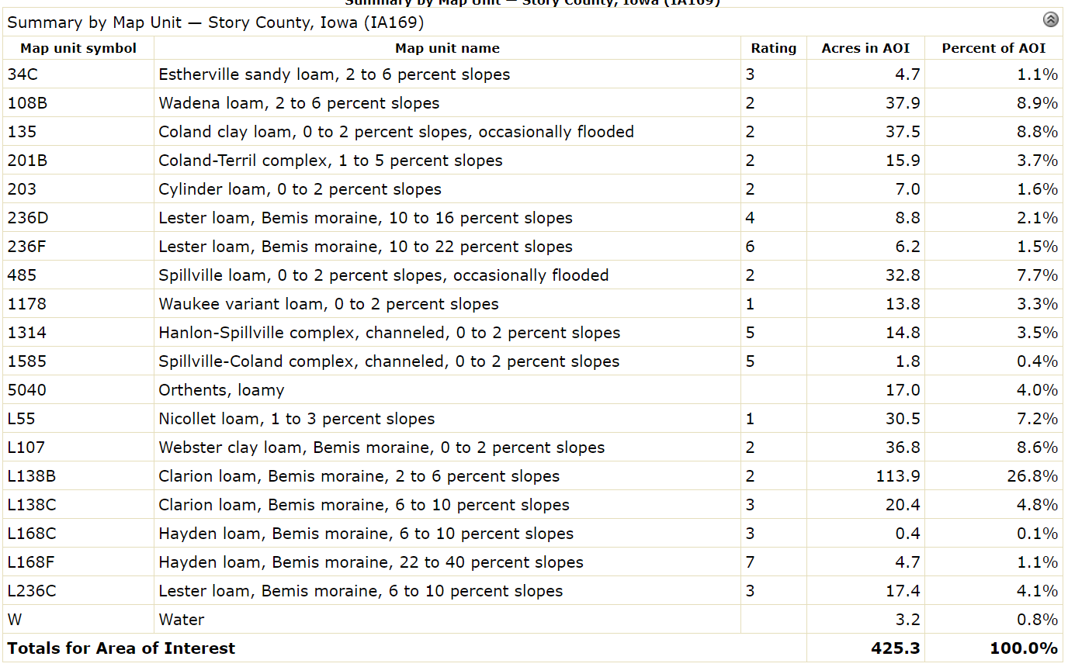

* 1. Provide short explanations for each of the classes.

Capability classes, the broadest groups, are designated by the numbers 1 through 8. The numbers indicate progressively greater limitations and narrower choices for practical use. The classes are defined as follows:  
  
Class 1 soils have few limitations that restrict their use.  
  
Class 2 soils have moderate limitations that reduce the choice of plants or that require moderate conservation practices.  
  
Class 3 soils have severe limitations that reduce the choice of plants or that require special conservation practices, or both.  
  
Class 4 soils have very severe limitations that reduce the choice of plants or that require very careful management, or both.  
  
Class 5 soils are subject to little or no erosion but have other limitations, impractical to remove, that restrict their use mainly to pasture, rangeland, forestland, or wildlife habitat.  
  
Class 6 soils have severe limitations that make them generally unsuitable for cultivation and that restrict their use mainly to pasture, rangeland, forestland, or wildlife habitat.  
  
Class 7 soils have very severe limitations that make them unsuitable for cultivation and that restrict their use mainly to grazing, forestland, or wildlife habitat.  
  
Class 8 soils and miscellaneous areas have limitations that preclude commercial plant production and that restrict their use to recreational purposes, wildlife habitat, watershed, or esthetic purposes.